MINI PROJECT

(2020-21)

MEDICAL IMAGE PROCESSING

END-TERM REPORT



Institute of Engineering & Technology

Submitted by-
Ayushi Rathi (181500184)
Ayushi Srivastava (181500185)
Rozi (181500595)
Prashant Chaudhary (181500488)
Yugam (181500836)

Supervised By: -

Mr. Mandeep Singh

Technical Trainer

Department of Computer Engineering & Application
Contents

- Certificate
- Synopsis
- Acknowledgement
- Abstract
- Retinal Imaging
- Overview of the project
  - Optical Coherence Tomography
  - Importance of retinal OCT and its segmentation
  - Existing challenges associated with OCT imaging and segmentation
- Aim of the Project
- Automatic Layer Segmentation Algorithm
  - Image Down sampling
  - NFL-OPL and IS-RPE Separation
  - Calculating Graph Weights
  - Limiting the Search Region and Finding the Shortest Path
  - Repeat for Subsequent Layer Boundaries
- Images
  - Different Layers of Retina
  - A sample OCT image of a section of the retina of a visually healthy adult
  - Automatic segmentation flow chart showing the core steps in a new automatic algorithm for segmenting images of eyes with AMD
  - Sample Images for Project
- Code
  - Shortest Distance in the 4x4 Image Matrix
  - Shortest Distance in OCT Image

Certificate

This is to certify that Ayushi Rathi, Ayushi Srivastava, Rozi, Prashant Chaudhary and Yugam students of B. Tech (CSE) 3rd year has successfully Completed the MINI PROJECT named MEDICAL IMAGE PROCESSING on Digital Image Processing under the Guidance of Mr. Mandeep Singh Sir During 2020-21.

Signature:
Mr. Mandeep Singh Sir
(Technical Trainer)


PROJECT TOPIC: MEDICAL IMAGE PROCESSING

Project Group Members:

- Ayushi Rathi (181500184)
- Ayushi Srivastava (181500185)
- Rozi (181500595)
- Prashant Chaudhary (181500488)
- Yugam (181500836)

Project Mentor: Mr. Mandeep Singh (Technical Trainer)

About the Project: Optical Coherence Tomography (OCT) is a fast and non-invasive medical imaging technique which helps in the investigation of each individual retinal layer structure. For early detection of retinal diseases and the study of their progression, segmentation of the OCT images into the distinct layers of the retina plays a crucial role. However, segmentation done by the clinicians manually is extremely tedious, time-consuming and variable with respect to the expertise level. Hence, there is an utmost necessity to develop an automated segmentation algorithm for retinal OCT images which is fast, accurate, and eases clinical decision making.

Motivation: It is driven by the motivation to segment the various layers of retina in an OCT image using graph-theoretical methods to reduce the complexity of computational logic, optimize the processing time, and improve upon accuracy of layer detection.

Future Scope: A comprehensive and fully automatic method for annotation of retinal layers in OCT images. This will provide the most basic but yet important structural information to the original raw data, and serve as a starting step for any further and large-scale healthcare analytics.

Tools required:
- Hardware Requirements:
Processor | i5 8th Gen
Operating System | Windows 10
RAM | 4GB
Hard Disk | 1 TB
Display | 1920 X 1080
- Software Requirements:

Technology Used | Digital Image Processing
Tool Used | MATLAB

Signature of Project Guide: _____________________

Acknowledgment

We have taken efforts in this project. However, it would not have been possible without the kind support and help of many Teachers. I would like to extend my sincere thanks to all of them.

We are highly indebted to Mr. Mandeep Singh Sir for his guidance and constant supervision as well as for providing necessary information regarding the project & also for his support in completing the project.

We would like to express my gratitude towards our parents & member of GLA University for their kind co-operation and encouragement which help us in completion of this project.

Abstract

The report presents the three tasks that is being in continuation during college time at GLA University which are listed below:

1. Understanding of the Problem objective & implication.

2. Understanding of the data & building of the model.

3. Evaluation of the model.

All these tasks have been completed successfully and results were according to expectations. All the tasks were need very systematic approach, starting from the collection of the data to the implementation of the solution and till evaluation of the System. The most challenging task was the domain knowledge, to understand the language. It is one of the major areas and really need very fundamental and conceptual knowledge of Digital Image Processing and Matlab.

  - Retinal Imaging

Imaging of the cross-sectional anatomical structures of the retina is necessary for detection,
diagnosis and evaluating the effects of therapy for retinal diseases including macular
degeneration, glaucoma, and macular edema. There are several ocular imaging techniques
for cross-sectional imaging of the eye. However, most of the imaging techniques come with
their own set of challenges.
The limitation in the ocular tissue penetration capacity of ultrasound wavelengths restricts its
usage to the posterior segment of the eye. Similarly, magnetic resonance image is limited to
only a few hundred microns in terms of its penetrability and it cannot be implemented to take
cross-sectional images of the eye. Furthermore, ocular aberrations and size of the entrance
pupil of the eye limits the applicability of scanning laser ophthalmoscopy to image the
fundus.
These limitations have been overcome by the application of low-coherence interferometry
with continuous wavelengths of light sources on imaging to produce better visualization of
the retinal layers structures, in the form of optical coherence tomography imaging of the
retina.

1.2 Overview of the project

1.2.1 Optical Coherence Tomography

Optical coherence tomography (OCT) is a non-invasive medical imaging technique, which is
essentially a Michelson interferometer based on the principle of low-coherence interferometry. It works by the determination of magnitude of light intensity that has been reflected off a region of interest within organs such as eye, breast, skin, and kidney.

Optical coherence tomography is based on the principle of low coherence interferometry, where the time differences in seeing the structures depend on the distances between them. The beam from a low coherent light source is incident on a beam splitter. The light source is usually a bandwidth laser or a superluminescent diode. In Time Domain OCT (TD-OCT), the first half of the light rays emerging from the beam splitter is incident on a mirror located on the reference arm at a known location. The second half of light rays emerging from the beam splitter is scattered at the sample arm and reflected off the tissue structures being scanned. The light rays both from the reference arm as well as the sample arm goes back to the beam splitter to recombine and emerge from the other side as an interference pattern to be sensed by a photodetector. If the light rays scattered from the tissue structures and the light from the reference arm are approximately equidistant, then constructive interference takes place. The resolution of the interferometer depends on the width of the signal and is inversely proportional to the coherence length of the light, which is further dependent on the bandwidth.
However, Spectral Domain Optical Coherence Tomography (SD-OCT) images of the retina have been used for layer segmentation within this study. SD-OCT operates on a similar principle as TD-OCT with some variations. The mirror on the reference arm is stationary in case of SD-OCT. A grating act as a beam splitter which splits the interference pattern into its frequency components. Each of these frequency components are then detected by a charge-coupled device (CCD), which consists of a series of photodetectors. Each of the photodetectors within the CCD is capable of detecting a specific range of frequencies. The Fourier transform of the depth within the tissue structures is represented by each detected frequency, and contributes to a resulting A-scan. Additionally, this technique greatly improves upon the scanning speed as compared to TD-OCT.

1.2.2 Importance of retinal OCT and its segmentation

High resolution and interferometric sensitivity, and spectral transmission properties of the ocular media enables the application of OCT for fast and precise cross-sectional visualization of retinal layer structures2,14. However, for early detection and studying progression/remission of many ophthalmic and neurological diseases, it is important to
investigate individual sub-retinal layers, which is achieved by segmentation of OCT slices for accurate delineation of layer boundaries. Segmentation of spectral-domain Optical Coherence Tomography (SD-OCT) images facilitates visualization and quantification of subretinal layers for diagnosis of retinal pathologies. However, manual segmentation is subjective, expertise dependent, and time-consuming, which limits applicability of SD-OCT. Computational techniques such as active-contours, artificial intelligence, and graph-search are therefore implemented to automatically segment retinal layers with accuracy comparable to that of manual segmentation in order to ease clinical decision-making. Graph-based image segmentation approach stands out from the rest because of its ability to minimize the cost function while maximizing the flow.

1.2.3 Existing challenges associated with OCT imaging and segmentation

With increasing amount of volumetric imaging data, manual segmentation gets challenging,
time consuming, and subjective, thus limiting its applicability. The default segmentation
algorithms available with commercial OCT imaging devices are inconsistent within versions
and between manufacturers, with high dependence on image quality, exhibiting limited robustness when dealing with the pathological retina. Furthermore, poor image contrast due to high-reflectivity of some retinal layers and the presence of heavy speckle noise, pose severe challenges to the automated segmentation algorithms. A fast, accurate and robust automated segmentation algorithm is therefore needed that would transcend these
limitations.
However, noisy conditions within the retinal OCT images often make the task of automated segmentation computationally complex and time-consuming. It is therefore essential to make the scans noise-free or reduce the noise-level before accurate segmentation. Simple Gaussian filters used in graph-based segmentation algorithms over-smoothen the images in certain cases by filtering of high-frequency components of the image which result in blurring of edges, thus impacting the accurate detection of boundaries within the images. Other denoising methods have been proposed that took into account the difference between the noisy and noise-free images. One such technique reconstructed the bilaterally filtered images in a wavelet domain to retain the boundary details within the images.

1.3 Aim of the Project

This research is driven by the motivation to segment the various layers of retina in an OCT image using graph-theoretical methods to reduce the complexity of computational logic, optimize the processing time, and improve upon accuracy of layer detection by finding the best denoising technique for graph-based segmentation.

The specific goals for the thesis are as follows:

i. To delineate intra-retinal boundaries in retinal SD-OCT images.

ii. To compute retinal layer thicknesses which can be compared to histological thickness values to ease diagnosis of ocular diseases.

iii. To compare the effects of denoising in accurate boundary delineation.

iv. To validate the automated segmentation results by clinical experts.

2.1 Automatic Layer Segmentation Algorithm

We base our new three-retinal-layer boundary segmentation algorithm for SD-OCT images with AMD pathology on the generalized graph theory and dynamic programming framework that we previously introduced for normal retina. An outline of the new algorithm flow highlights the key components needed to adapt this method for images with drusen and GA, and an overview of the steps involved are described in the subsequent paragraphs.

2.1.1 Image Downsampling

To reduce the overall computation time, we first downsample the image by a factor two in both dimensions using bi-cubic interpolation and antialiasing. This step can be ignored for images with low resolution, or if the computational complexity is of no concern.

2.1.2 NFL-OPL and IS-RPE Separation

There are two distinct hyperreflective regions in a filtered SD-OCT image of the retina: the region bounded by the NFL and outer plexiform layer (denoted NFL OPL complex) and the region containing the inner segment– outer segment junction (IS-OS), RPE, and drusen (denoted IS-RPE complex). For retinal images with AMD, the pathology may result in a merging of
the NFL-OPL and IS-RPE complexes. If these two regions are not separated before segmenting, then it is possible for the ILM boundary and the inner boundary of the RPEDC to be mistaken for each other due to similarities in their characteristics.

We therefore generate a binary mask of the image to isolate the NFL-OPL and IS-RPE hyperreflective complexes, by smoothing the image with an 11-pixel Gaussian filter with a standard deviation of 11 pixels, extracting the edges with a [ 1;1] high-pass filter (using
MATLAB notation; The MathWorks, Natick, MA), normalizing the image to range from 0 to 1, generating a binary mask using a threshold of 0.5 on the normalized image, opening any gaps in the clusters using a 3 x 3 pixel structuring element, removing connected clusters smaller
than 200 pixels, and closing any remaining gaps using the same structuring element.
Once the mask is generated, we delineate the boundaries of the two white bands corresponding to the two NFL-OPL and OS-RPE complexes using graph theory and dynamic programming. We generate two vertical gradient adjacency matrices—a black-to-white and a white-to-black matrix— using the [ 1;1] and [1; 1] edge filters and set all negative values to 0. After automatic endpoint initialization, we segment the four boundaries in the image. We achieve this by twice
searching for a black-to-white edge to locate the upper boundaries of the two white bands and twice searching for a white-to-black edge to locate the two lower boundaries of the white bands. To ensure the same edge is not cut again, we exclude already delineated nodes from the graph when cutting subsequent edges. The result is a pilot estimate of the ILM, inner RPEDC, and Bruch’s membrane boundaries.

2.1.3 Image Flattening

Next, we flatten the image based on the convex hull38 of the estimated inner RPEDC boundary, by shifting the columns of the image up or down until the estimated convex hull lies on a flat line. To prevent introducing any new border artifacts, columns of the flattened image without pixel intensity information are assigned intensity values corresponding to the mirror image of the values in the valid regions of the same column.

2.1.4 Calculating Graph Weights

We then create adjacency matrices based on the flattened image. To delineate the ILM, weights assigned to a dark–light adjacency matrix are calculated based on equation 1:

where wab is the edge weight connecting nodes a and b, ga DL and ga DL are the vertical dark-to-light gradients of the image at nodes a and b, respectively, and wmin, the minimum weight of the graph, is 1 x 10⁻⁵. The normalize (x, y, z) notation indicates a normalization of the values x to range from y to z. For Bruch’s membrane, a separate adjacency matrix is used with weights calculated based on equation 2.

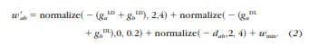

where ga LD and gb LD are the vertical light-to-dark gradients of the image at nodes a and b, respectively, and dab is the Euclidian distance from node a to node b. For the inner RPEDC boundary, the dark–light adjacency matrix from equation 1 is used along with a third adjacency matrix calculated based on image intensity, as shown in equation 3.

2.1.5 Limiting the Search Region and Finding the Shortest Path

After calculating the graph weights, we automatically initialize the endpoints and cut the layer boundaries using Dijkstra’s algorithm to find the shortest path. We cut the ILM using the dark–light adjacency matrix in a search region ranging from the top of the image to the inner boundary of the RPEDC estimated from the binary mask.

2.1.6 Repeat for Subsequent Layer Boundaries

To segment Bruch’s membrane, we first tentatively cut the inner boundary of the RPEDC using the dark–light adjacency matrix in a search region limited by the inner RPEDC and Bruch’s membrane boundaries estimated by the binary mask. To find the final cut for Bruch’s membrane, we use the second adjacency matrix with combined weights from equation 2 and the tentative inner boundary of the RPEDC as the upper search limit.

Images
Different Layers of Retina

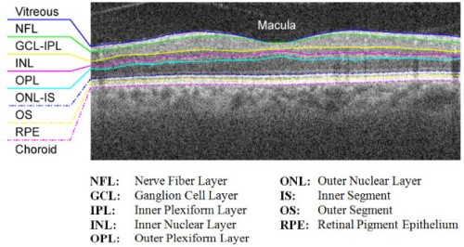

A sample OCT image of a section of the retina of a visually healthy adult

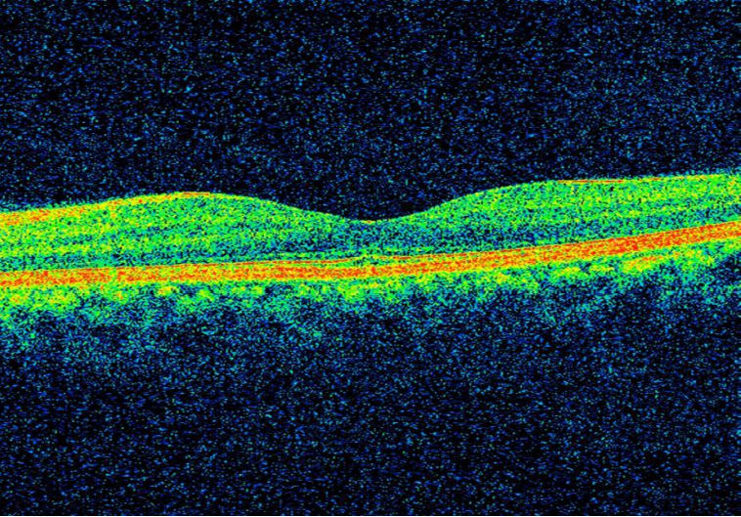
Automatic segmentation flow chart showing the core steps in a new automatic algorithm for segmenting images of eyes with AMD

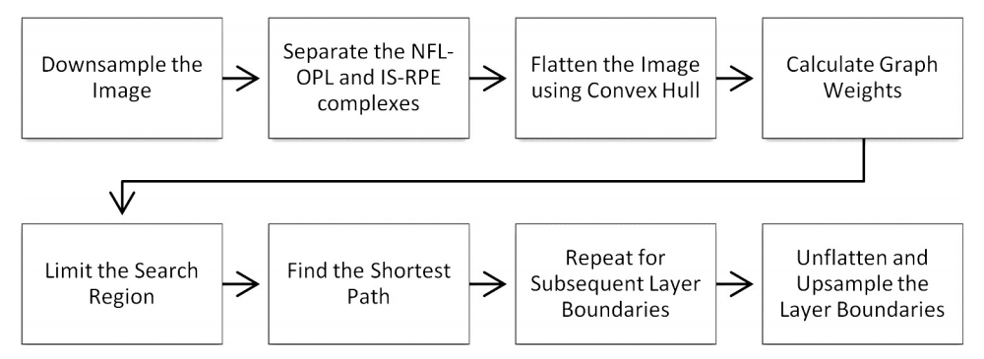

Sample Images for Project

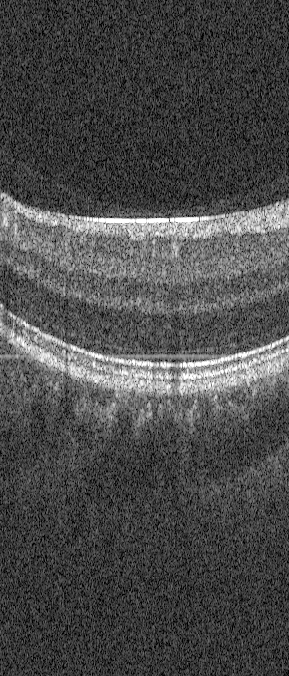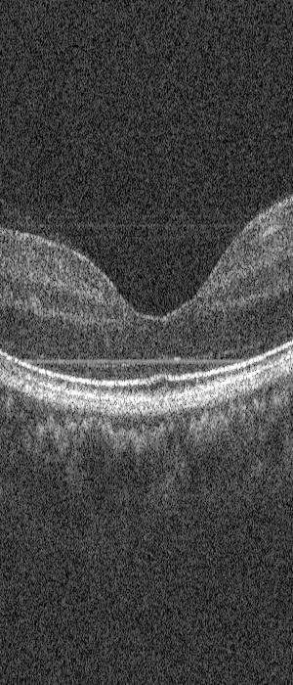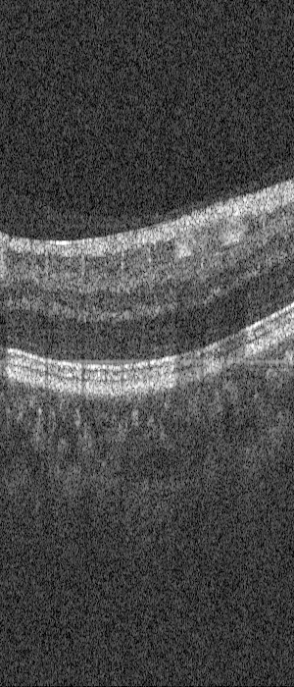

Code

Shortest Distance in the 4x4 Image Matrix

Img = imread('D:\Matlab\Project\Images\img.jpg');
Img1 = rgb2gray(Img);
Img2 = double(imresize(Img1,[4 4]));
Img3 = imresize(Img1,[4 4]);

n = 4;
N = (n*(n-1))*2;
s=zeros(1,N);
t=zeros(1,N);
rows=zeros(1,n*n);
cols=zeros(1,n*n);
weights = zeros(1,N);

% s & t calculation
r=n;
c=n;
I=zeros(r,c);
x = 1;
for i=1:r
for j=1:c
I(i,j) = x;
rows(1,x)=i;
cols(1,x)=j;
x = x+1;
end
end

% For Horizontal
si = 1;
for i=1:r
for j=1:c-1
if (((j+1)-j) == 1)
s(1,si) = I(i,j);
t(1,si) = I(i,j+1);
si = si + 1;
end
end
end

% For Verticle
for i=1:r
for j=1:c-1
if (((j+1)-j) == 1)
s(1,si) = I(j,i);
t(1,si) = I(j+1,i);
si = si + 1;
end
end
end

% Weight Calculation
% For Horizontal Edges
[r,c] = size(Img2);
x = 1;
for i=1:r
for j=1:c-1
I1 = (Img2(i,j) - 0)/(255 - 0);
I2 = (Img2(i,j+1) - 0)/(255 - 0);
w = 2 - (double(I1)+double(I2)) + 10.^(-5);
weights(1,x) = w;
x = x + 1;
end
end

% For Verticle Edges
for i=1:r
for j=1:c-1
I1 = (Img2(j,i) - 0)/(255 - 0);
I2 = (Img2(j+1,i) - 0)/(255 - 0);
w = 2 - (double(I1)+double(I2)) + 10.^(-5);
weights(1,x) = w;
x = x + 1;
end
end

G = digraph(s,t,weights);
path = shortestpath(G,1,n*n);
[psr psc] = size(path);
u=zeros(1,psc);
v=zeros(1,psc);

for i=1:psc
y=path(i);
u(1,i)=rows(1,y);
v(1,i)=cols(1,y);
end

[ur uc] = size(u);
for i=1:uc
a = u(1,i);
b = v(1,i);
Img3(a,b) = 255;
end

p = plot(G,'Layout','force','EdgeLabel',G.Edges.Weight);
highlight(p,path,'EdgeColor','r','NodeColor','r')

Output :

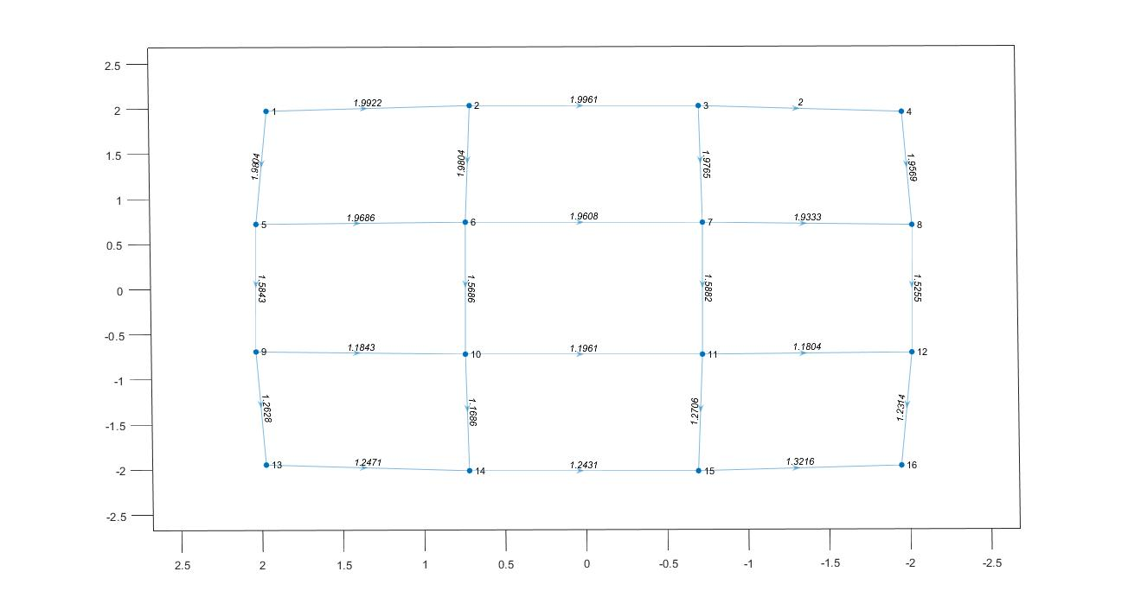

4x4 Image Matrix

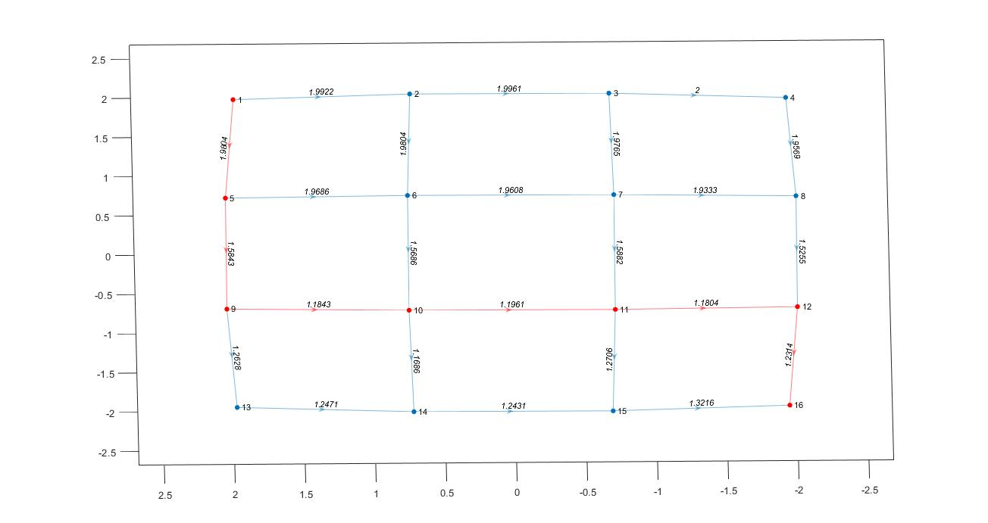
4x4 Image Matrix with Shortest Path

Shortest Distance in OCT Image

Img = imread('D:\Matlab\Project\Images\img.jpg');
Img1 = rgb2gray(Img);
Img2 = double(imresize(Img1,[500 500]));
Img4 = imresize(Img1,[500 500]);
Img3 = padarray(Img4,[0 1],255);

n = 500;
N = (n*(n-1))*2;
s=zeros(1,N);
t=zeros(1,N);
rows=zeros(1,n*n);
cols=zeros(1,n*n);
weights = zeros(1,N);

% s & t calculation
r=n;
c=n;
I=zeros(r,c);
x = 1;
for i=1:r
for j=1:c
I(i,j) = x;
rows(1,x)=i;
cols(1,x)=j;
x = x+1;
end
end

% For Horizontal
si = 1;
for i=1:r
for j=1:c-1
if (((j+1)-j) == 1)
s(1,si) = I(i,j);
t(1,si) = I(i,j+1);
si = si + 1;
end
end
end

% For Verticle
for i=1:r
for j=1:c-1
if (((j+1)-j) == 1)
s(1,si) = I(j,i);
t(1,si) = I(j+1,i);
si = si + 1;
end
end
end

% Weight Calculation
% For Horizontal Edges
[r,c] = size(Img2);
x = 1;
for i=1:r
for j=1:c-1
I1 = (Img2(i,j) - 0)/(255 - 0);
I2 = (Img2(i,j+1) - 0)/(255 - 0);
w = 2 - (double(I1)+double(I2)) + 10.^(-5);
weights(1,x) = w;
x = x + 1;
end
end

% For Verticle Edges
for i=1:r
for j=1:c-1
I1 = (Img2(j,i) - 0)/(255 - 0);
I2 = (Img2(j+1,i) - 0)/(255 - 0);
w = 2 - (double(I1)+double(I2)) + 10.^(-5);
weights(1,x) = w;
x = x + 1;
end
end

G = digraph(s,t,weights);
path = shortestpath(G,1,n*n);
[psr psc] = size(path);
u=zeros(1,psc);
v=zeros(1,psc);

for i=1:psc
y=path(i);
u(1,i)=rows(1,y);
v(1,i)=cols(1,y);
end

[ur uc] = size(u);
for i=1:uc
a = u(1,i);
b = v(1,i);
Img3(a,b) = 255;
end

imshow(Img3);

Output :
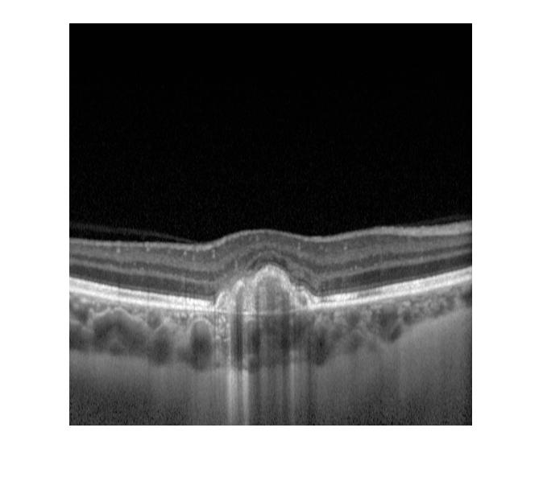
OCT Image

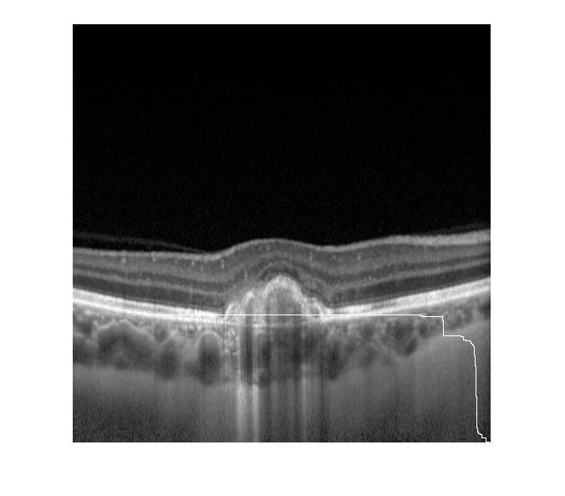

OCT Image with Shortest Path



